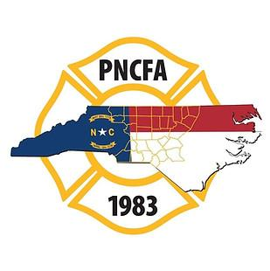
`

Piedmont North Carolina Firefighters’ Association
Quarterly Membership Meeting
July 26, 2023
NC Air National Guard/OSFM Training Center

Call to order
President Brian Causey called the meeting to order at 6:30 PM.

Prayer
Mike Williams held the opening prayer and blessing of the meal.

Opening Remarks
President Causey thanked OSFM and the NC Air National Guard and Staff for hosting the meeting and Fire Connections sponsoring the meal for the meeting. President Causey recognized Insurance Commissioner Causey, Brian Taylor with OSFM, and State Representative Sasser.

Introduction of the Board: President Causey welcomed everyone. He introduced the PNCFA Board of Directors:
Brian Causey, President | Chad Garrett, North Director
Scott Hackler, First Vice-President | Steven Roberson, Past President
Johnny Blythe, Second Vice-President | Ed Brinson, Treasurer
Chris White, South Director

Meeting Host/Vendor Comments
President Causey recognized other PNCFA sponsors

Lifetime Membership Presentations
President Causey presented Past President Ron Fowler with his Lifetime Membership certificate.

Scholarship Presentations
President Causey presented PNCFA scholarships to the following recipients:
Ian Jones Ted Armstrong High School Associate’s Degree
Lela Philemon Jerry Brooks High School Bachelor’s Degree
Katelyn Belton Chris Hooper Firefighter’s Associate’s Degree
Edward Hampton Donald Whitaker Firefighter’s Bachelor’s Degree
Justin Lanning Bobby T. Wilson Master’s Degree

Meeting Minutes
The minutes from the April 26, 2023 association meeting were presented for approval. Copies were distributed to all attendees. Tim Bradley motioned to approve the minutes. Chris Davis seconded the motion. The vote was unanimous.

Treasurer’s Report
Ed Brinson presented the details of the Treasurer's report. Copies were distributed to all attendees. Jerry Brooks motioned to approve the Treasurer’s report. Eric Hoffman seconded the report. The vote was unanimous.

Agency Reports
NCSFA-Tim Bradley
NCAFC-Wesley Hutchins
NCAFMA-Carmon
NCFFF-Tim O’Loane and David Swaim
OSFM-Brian Taylor
Southeastern Association of Fire Chiefs-Jennifer Smith
NC Community College-
NC Emergency Management-
NVFC- Quinten Cash

Old Business
No old business came before the membership.

New Business

October Election of Officers
President Causey introduced the three candidates running for the North Director position.
David Swaim from the Drewry Fire Department, David Swaim from the Durham Fire Department, and Jamie Fore from the Old Richmond Fire Department. President Causey opened the floor for nominations. No nominations were received from the floor and nominations were closed. Each candidate was given 5 minutes to speak to the membership. A vote will be held at the October meeting.

President Causey informed the membership the position for Treasurer was up for election. President Causey advised one candidate has submit their name for treasurer, Ed Brinson. President Causey opened the floor for nominations for treasurer. No nominations were received from the floor and nominations were closed. Ed Brinson

Next Meeting
The next meeting will be held at the Elkin Fire Department on October 25th.

Adjournment
President Causey adjourned the meeting at 8:00 PM.

