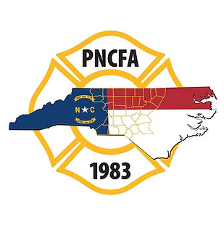
`

Piedmont North Carolina Firefighter’s Association
Second Quarter Membership Meeting
April 26, 2023
Randolph County Emergency Training Center

Call to order
President Brian Causey called the meeting to order at 6:36 PM.

Welcoming Remarks
Welcoming remarks were provided by President Causey, Interim President Elbert Lassiter from Randolph County Community College, County Commissioner Kenny Kidd, and Randolph County Chiefs’ Association President Hoffman.

Introduction of the Board: President Causey welcomed everyone. He introduced the PNCFA Board of Directors: Brian Causey, President
Scott Hackler, First Vice-President,
Johnny Blythe, Second Vice-President,
Chad Garrett, North Director,
Chris White, South Director,
Steven Roberson, Past President
Ed Brinson, Treasurer.

Meeting Host/Vendor Comments
President Causey thanked CIVIC for the meal sponsorship and provided them an opportunity to speak. Sherrod Warwick, Loren Pittman, and Jason Rackley from CIVIC provided an overview of the mission of the credit union, services and programs offered by the credit union. Sherrod Warwick spoke on the LGFCU moving to independence from SECU and the enhanced services they will provide in the future.

President Causey recognized the other vendors that were present for the meeting.

Prayer
________________gave the invocation and blessed the evening meal.

Meeting Minutes
The minutes from the January 25, 2023 association meeting were presented for approval. Copies were distributed to all attendees. Charles Holtzman motioned to approve the minutes. Brian Cox seconded the motion. The vote was unanimous.

Scholarship Awards
President Causey announced the scholarship winners as follows:
Ian Jones Ted Armstrong High School Associate’s Degree
Lela Philemon Jerry Brooks High School Bachelor’s Degree
Katelyn Belton Chris Hooper Firefighter’s Associate’s Degree
Edward Hampton Donald Whitaker Firefighter’s Bachelor’s Degree
Justin Lanning Bobby T. Wilson Master’s Degree

Treasurer’s Report
Ed Brinson presented the details of Treasurer’s report. Copies were distributed to all attendees. Jerry Brooks from Clemmons motioned to approve the Treasurer’s report. Derrick Carson from Pinecroft-Sedgefield seconded the report. The vote was unanimous.

Agency Reports
NCSFA-Tim Bradley
NCAFC-Wesley Hutchins
NC IAAI-Jerry Coble
NCFFF-Rick Wood
OSFM-Mike Williams and Brian Taylor
SEAFC-Len Needham
NCFLSE-Jeanne Wood

Old Business
President Causey announced that Timothy O’Loane has been selected by the PNCFA to serve as the association’s representative on the NCFFF.

Next Meeting
The next meeting will be held at the NC Air National Guard Facility in New London on July 26, 2023

Adjournment
President Causey adjourned the meeting at 9:15 PM.

