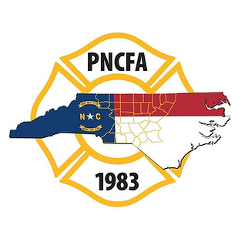
`

Piedmont North Carolina Firefighter’s Association
First Quarter Membership Meeting
January 24, 2024
Sandford Fire Department, Lee County

Call to order
President Brian Causey called the meeting to order at 6:30 PM.

Welcoming Remarks
Welcoming remarks were provided by President Causey and Sanford Fire Department Assistant Chief Cotton on behalf of Chief Arnold.

Meeting Host/Vendor Comments
President Causey thanked Atlantic Emergency Services for the meal sponsorship and provided them an opportunity to speak.

President Causey recognized the other vendors that were present for the meeting.

Prayer
Assistant Chief Chris Davis gave the invocation and blessed the evening meal.

Meeting Minutes
The minutes from the July 26, 2023, association meeting was presented for approval. Minutes were posted to the PNCFA website. Chirs Davis motioned to approve the minutes. Bradley Dick seconded the motion. The vote was unanimous.

Treasurer’s Report
Ed Brinson presented the details of the Treasurer’s report. Copies were distributed to all attendees. Jery Brooks motioned to approve the Treasurer’s report. Scott Hampton seconded the report. The vote was unanimous.
- Saving = $52.61
- Money Market = $19,869.33
- Civic Share = $20,003.12
- Checking = $2,744.02
- Total of all for all accounts $42,669.08

Old Business
None

Installation of 2024 PNCFA Officers:
- Past President and Retired Fire Chief Jerry Brooks conducted the Officer installation ceremony.
- 2024 Officers:
  - President Scott Hackler
  - 1st Vice-President Johnny Blythe
  - 2nd Vice-President Chad Garrett
  - Northern Director Jamie Fore
  - Southern Director Chris White
  - Past President Brian Causey
  - Treasurer Ed Brinson
New Business
- NCAFC Piedmont representative.
  - Nominations opened for Piedmont representative to the NCAFC. Johnny Blythe was nominated by the PNCFA board. No further nominations were made, and Chris Davis motioned for nominations to be closed and Ron Fowler seconded the motion. President Hackler will notify the NCAFC Johnny Blythe will be the PNCFA representative.
- President Hackler notified all in attendance the PNCFA scholarships and grants are open.

Agency Reports
NCSFA-Tim Bradley & Ed Brinson attached.
NCAFC-Brian Causey attached.
NCFMA -Bobby Cameron Attached
NC IAAI-No report
NCFFF- attached.
OSFM- attached.
SEAFC-No report
NCFLSE-No report
N.C. Community College – No report
N.C. Emergency Management – No report
NVFC – attached.

Roll call by county.

Next Meeting
The next meeting will be held in Orange County hosted by the Efland Fire Department on April 24, 2024, beginning at 6:30 PM

Adjournment
President Causey adjourned the meeting at 7:55 PM.

NCSFA Report

Roster Reporting Requirements
Rosters are/were due by January 15th. This includes the Board of Trustees Report, membership roster, as well as the certification of firefighters.
Relief Fund Update
Last year continued to be an extremely active year for relief fund usage and approval. Last year continued to be an extremely active year for relief fund usage and approval. We handled 602 requests as opposed to 566 requests in 2022, for a total of $2,950,273.19. That was a $359,222.00 increase over 2022. The highest type of requests were supplemental insurance followed by supplemental retirement pay.
I would remind everyone that it is critical for those at or near their maximum of $2,500 per rostered firefighter to watch their balance closely. We still have fire departments submitting reports that are over their maximum. This will result in them not being able to receive their check at the end of the fiscal year from DOI. Several departments with investment accounts exceeded their maximum this year due to increased investment results, so monitor your accounts for growth rather than relying on the usual balance.
Scholarship and Grants
Scholarships opening will be delayed for 2024. We have several IT Changes that need to be made in the applications for the changes to NFPA Certification requirements.
There are 15 scholarships per region awarded each year. The scholarships include $2,000 Associate’s, $8,000 bachelor’s and $10,000 master’s degree awards.
We also have (8) $500 training grants available per region. We hope it expands in the future.
The electronic submission due date for the scholarship and grant applications is March 15, but we will extend that date due to the delay in opening.
Legislation
Legislative Priorities for 2023/2024 Session
In late 2022 the NCSFA and the NCAFC’s held a joint Legislative Committee meeting to discuss legislative priorities for the current 2023/2024 session. The short session begins in late March, and our indication is they will only be in session for about 6-8 weeks. We will continue to focus on our established priorities that were not completed in 2023.
Concerns for the short session include:
- The budget passed and did not include the language from SB 326 which would have permanently funded cancer and kept workers comp (VSWCF) reserves funded at an adequate level. We want to secure the permanent funding source for the future.

As previously reported, HB 378 has been signed into Law as Chapter Law 2023-104. Here is a reminder of what that includes.

HB 378, which is now law, allows for three variations of criminal background checks normally requiring fingerprints, if the applicant or member has lived in NC for more than five consecutive years. They are:
(1) A statewide criminal history record check without fingerprints may be conducted by the North Carolina Department of Public Safety. The requesting entity shall provide to the North Carolina Department of Public Safety any information required by the Department to conduct a name only search and a form signed by the State resident to be checked consenting to the check of the criminal record and use of other identifying information required by the State Repository. The name and other required information shall be forwarded to the State Bureau of Investigation for a search of the State criminal history record file.
(2) A statewide criminal history record check of the State resident's name may be conducted by a third-party vendor. The requesting entity and State resident shall provide the third-party vendor's required documentation to complete the request.
(3) A statewide criminal history record check of the State resident's name may be conducted and certified by the clerk of court, at the clerk's discretion.

In addition, applicants for junior membership and current junior members of a fire department under the age of 18 shall be exempt from the criminal history record check.

A reminder of our priorities and where they stand in correlation to the budget:

- Increase in Fire and Rescue Pension Benefits. This would include a $5 increase in benefits with a $5 increase in premiums. SB 728 has been introduced increasing the pension to $200 per month, but did not make crossover, but HB 270 with a $5 increase has passed the House and may be included in the budget. A potential increase of more is an option, but until the budget is released, we won’t know much more. The possibilities include no increase at all; $5.00 per month; or another amount that may be negotiated.
- Secure continuation funding for the Cancer Insurance Pilot Program going into the future.
- Oppose any legislative increase in use or sale of fireworks. The Fireworks bill introduced did not make crossover.
Monitor and discuss any additional legislation.

Federal Legislation – We continue to Pursue Changes to IRS Regulations that could allow non-profit career firefighters in LGERS.
Legislative Day Legislative Day has not been scheduled for this year. More information will be coming out in the future as planning proceeds.
Legislative Tracking Software – We have legislative tracking software called Engagifi. If you want to track legislative progress on fire service issues, you can sign up on our website NCSFA.com under Legislation. We currently have about 2,300 advocates signed up.

BCBS Grants, PTSD and Cancer Screening
In 2021, Blue Cross contributed $500,000 to our non-profit organization, the North Carolina Firefighters Fund, to use in fire service programs with the NCSFA. Half of it went in the form of direct grants to small rural departments through OSFM like the previous year’s grant, but $250,000 was to be used to provide assistance to firefighters seeking treatment and assistance with PTSD and mental health issues. An application is available that Chiefs can submit on behalf of their personnel. To date we have assisted 42 individuals with awards of over $74,000.

We also received a grant from BCBS ($200,000) for an additional amount to offer grants to volunteer departments to be used for Cancer Screening in December. We plan to offer funding to be used to supplement efforts to provide screening for early detection of cancer. More information will be coming out in the near future on how to apply for these grants.
SAFRE Conference
The 2024 SAFRE Conference will be held at the Raleigh Convention Center August 7th-11th, 2024. The theme for this year is Learn-Lead-Mentor.
Online registration will be available in the next couple of weeks. Course selections have already been made and I can tell you this year we will have some great classes. Our keynote address for 2024 will be given by Fire Chief, international speaker, and best-selling author Frank Viscuso. Chief Viscuso wrote Step up and Lead and Common Valor, among several other bestselling books. He has also delivered keynote addresses and classes all over the world, including at FDIC. We are excited to welcome Chief Viscuso to SAFRE in 2024 for his keynote address, as well as a 4-hour seminar on leadership in the fire service.
We’ll have more as the time grows closer, but with the lineup of classes, exhibitors and activities this will be one SAFRE not to miss so please mark your calendar for that week. We look forward to a great week of fellowship, education and seeing what’s new and innovative in apparatus, technology and equipment for the fire service and our first responders.
Summit
We currently plan on hosting a Summit Tuesday again this year this year like we did last year. This will include the Board members from the NCSFA, NCAFC’s, and the Boards from all three regional associations (Western, Eastern, and Piedmont). It will also include representatives from the Fire Marshal’s Association and OSFM. More will be provided as we get nearer to the Date.
VFIS Member Family Assistance Program
When we changed insurance carriers the old FRAP program went away, but we have a new assistance program to help enable personnel and their families to resolve personal and work-related issues to maintain health and wellness. Posters have gone out to all departments listing the new number 866 349 5579. This combined with our PTS assistance program for therapy and counseling provides some assistance to those struggling with emotional and stress issues.
Memorial Service List of Members Who Have Passed Away
Chiefs’, please submit the name to us throughout the year of any members or retirees that pass away so we can add them to our memorial service list at conference.

North Carolina Association of Fire Chiefs Quarterly Report
January 2024
- The annual NCAFC mid-winter conference will be in Concord, NC January 29 – February 2, 2024. The trade/vendor exhibition is sold out and we look forward to a great educational program and our keynote speakers will be in our morning sessions on Wednesday and Thursday. On Thursday morning we will also recognize the class of 2023 Lifetime members. The banquet on Friday evening will recognize the Fire Chiefs and Fire Officers of the Year.

- NCAFC will co-host the annual Fire Prevention School. The school will be back in Carolina Beach March 18 – 23,2024. All sessions are filled, and the host hotel is full. If you would like to be on the stand-by list please contact the Fire Prevention School Coordinator, Braxton Tanner.

- Recruitment and Retention grants to assist North Carolina Volunteer Fire Departments with their initiatives on recruiting and retaining members have been awarded and there will be a meeting at the mid-winter conference in reference to the grant and updates on initiatives and programs associated with the grants.

- NCAFC License plate ordering information can be found on our website. Keep in mind that portions of the plate purchase and renewals come back to the NC Association of Fire Chiefs to assist with educational programs.

NORTH CAROLINA OFFICE OF STATE FIRE MARSHAL
- Brian Taylor provided the following report:
  - OSFM is now an independent agency under the umbrella of the Department of Insurance
  - Provided update on the transition.
  - Thanks everyone during the transition.
  - Grants are open with applications on our website.
  - FEMA Fire Act grants are open.

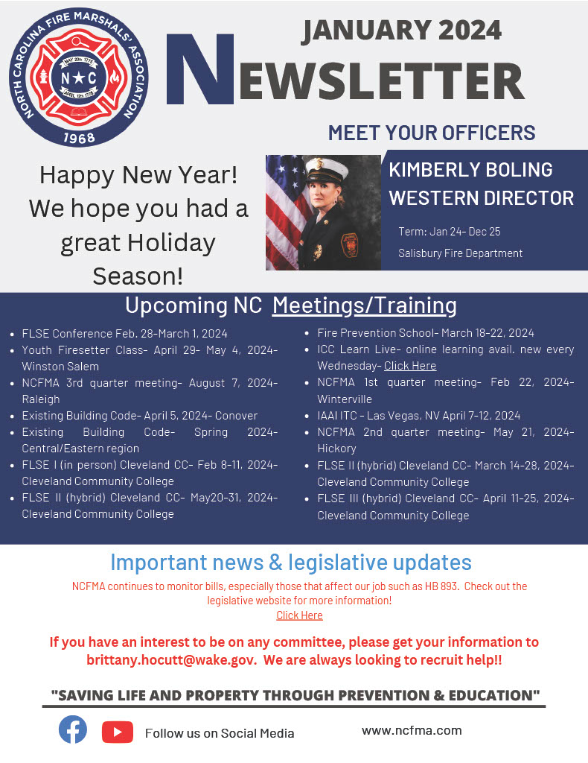
NORTH CAROLINA FALLEN FIREFIGHTERS’ FOUNDATION
PO BOX 144, MOCKSVILLE, NC 27028
(910) 388-7464
www.ncfff.org

Quarterly Regional Report
January 2024

January 6, 2024, The NCFFF Board of Directors held our first meeting of the New Year at Holly Springs Fire Department in Holly Springs, NC. Board discussed several topics to include:

Memorial Design and expansion and cost.

Sponsorship Programs

2024 Memorial Planning

Fundraising events

2023 LODD Inductees

The Memorial Expansion Committee presented a design that would allow the addition of names to the memorial that should last for over the next 100 years. The design stays within the existing memorial circle and would consist of adding a wall with granite tablets on the 4 brick walls surrounding the monument. This design would also include lighting for each new section. Pictures of the design are available for everyone to review. This design would allow for expansion but remain within the footprint of the current memorial circle located in Nash Square. Projected cost is between $900,000 to 1 million dollars with adjustments.

In order to proceed with the project, the Foundation is looking for continued sponsors, grants and fundraising opportunities in order to secure funding. Construction on the expansion will not start until funding is secured. We are also looking for sponsors to assist with the Annual Memorial Service held the 2nd weekend in May at the memorial site in downtown Raleigh inside Nash Square. Handouts are available to anyone wishing to assist the Foundation with either, or both, the Memorial Expansion or the Annual Memorial.

World Fun Vacations is putting together a 7-night Cruise to the Eastern Caribbean to benefit the NCFFF. The cruise is set to depart on January 11, 2025. Go to our website or Facebook page for more information. The Foundation is also working on a 5-day cruise departing Charleston SC for our Surviving Families departing on November 4th, 2024, thru November 9th, 2024. Surviving Families can contact Kathy Guyer-Martin for additional information.

The Foundation Board discussed and complied the 2023 list of names for induction into Fallen Firefighters Memorial on May 11th, 2024. The following fallen firefighters will be inducted:

Van Boles | Pinnacle Vol Fire Rescue
Minton Beach III | Oak City
James W Goudelock | Dallas Fire
Jeremy Klemm | Durham Fire
David Scott Holmes | LaGrange
David S Merritt | Durham/White Cross FD
Ricky Dale Allen | City of Conover
Scott W Hinson | Concord
J Sorrell Thomas | Concord
Dewayne Fender | Asheville

The Foundation has set up our own email system with Microsoft. It is position based,

Rick Fleming, President@NCFFF.onmicrosoft.com
Mike Brown, 1stVicePresident@NCFFF.onmicrosoft.com
Rick Wood, 2ndVicePresident@NCFFF.onmicrosoft.com
Kathy Guyer-Martin, Secretary@NCFFF.onmicrosoft.ocm
Lisa Welch, Treasurer@NCFFF.onmicrosoft.com
Dana McKim, Chaplain@NCFFF.onmicrosoft.com
Kevin Davis, Marketing@NCFFF.onmicrosoft.com
Jeff Harky, PIO@NCFFF.onmicrosoft.com

Don Hussey, Board1@NCFFF.onmicrosoft.com
Bryan Southard, Board2@NCFFF.onmicrosoft.com
Jerry Long, Board3@NCFFF.Onmicrosoft.com

Dennis Mathney, Western1@NCFFF.onmicrosoft.com
Chris Hicks, Western2@NCFFF.onmicrosoft.com
David Swain, Piedmont1@NCFFF.onmicrosoft.com
Tim O’Loane, Piedmont2@NCFFF.onmicrosoft.com
Jeffrey Shaw Eastern1@NCFFF.onmicrosoft.com
Kevin McDonald, Eastern2@NCFFF.onmicrosoft.com
Mike Williams, OSFM@NCFFF.onmicrosoft.com
Adam Moore, Piper@NCFFF.onmicrosoft.com
Glen Conley, NCFS@NCFFF.onmicrosoft.com

Board@NCFFF.onmicrosoft.com

The NCFFF will be at the Mid-Winter Chief’s Conference January 31st through Feb 2nd. Please stop by our booth and support the Foundation, obtain information on the Memorial Expansion, The Annual Memorial Service in May, the Logistical Support Team, or any information we can provide or assistance we can help with.

Respectfully Submitted,
Rick Wood2nd Vice President NCFFF
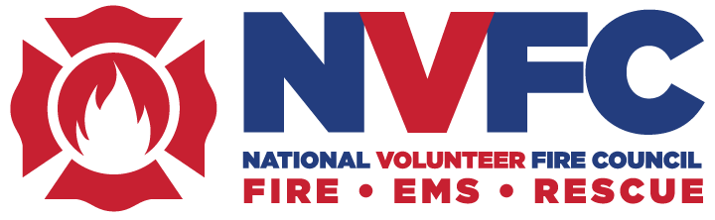

January 2024 Regional Association Meeting Updates/Notes:

Training Summit: Registration is now open for the NVFC Training Summit, taking place June 21-22 in Buffalo, NY. This signature conference, which celebrates its 10th anniversary this year, features classroom training, idea sharing, and networking. Three learning tracks focus on responder health and safety, volunteer recruitment and retention, and emergency service leadership. Travel stipends are available. More information can be found below after upcoming events.
Achievement Awards: There is still time to submit nominations for the NVFC’s four national fire service awards recognizing lifetime achievement, health and safety leadership, junior firefighter, and junior firefighter program. The nomination deadline is January 19.
Cancer Prevention: January is Firefighter Cancer Awareness Month, and the NVFC has free resources available to help responders reduce their risks and protect themselves from harmful exposures. This includes the Lavender Ribbon Report and our new Everyday Heroes video series that highlight best practices for on the fireground and after the incident.
Writing Workshop for Resilience: Routine exposure to traumatic events can have long-lasting consequences on the wellbeing of emergency responders. Building resiliency can help mitigate these impacts, and one way to build and sustain resiliency is writing. The NVFC has partnered with author and first responder Ali Rothrock to offer a three-part workshop that will show participants how journaling and writing can provide an always-accessible place to express and deepen personal resilience. An article is below after the Training Summitt Information.
Upcoming Events: The NVFC is offering three free, virtual, live training events in January. Suggested social media posts are attached.
- Webinar: Staying Strong and Aging Well in the Fire Service, January 10 at 2pm ET
- Roundtable Talk: Cancer Risk Prevention, January 17 at 2pm ET
- Webinar: Introduction to Emergency Response for Tesla Vehicles, January 24 at 2pm ET

2024 NVFC Training Summit

Registration is open for the National Volunteer Fire Council’s (NVFC) 2024 Training Summit, taking place June 21-22 in Buffalo, NY. This signature conference, which celebrates its 10th anniversary this year, provides an opportunity for firefighters and EMS providers to participate in valuable classroom training, idea sharing, and networking. Three learning tracks will focus on responder health and safety, volunteer recruitment and retention, and emergency service leadership.

The Summit includes two days of classroom-based breakout sessions with nationally known instructors, keynote speakers, general sessions, networking events, and a vendor expo. The agenda features a selection of 18 courses relating to critical topics impacting the volunteer emergency services, with a focus on physical and behavioral health, safety considerations during different types of response and training, recruiting new volunteer responders, best practices for retaining volunteers, and leadership. View agenda.

While the Training Summit is a great value, the NVFC recognizes that cost can be a challenge. To remove this barrier and help offset the costs, stipends are available that reimburse up to $800 of conference-related expenses, including hotel, airfare/mileage/transportation, and the event registration fee. To be eligible for a stipend, you must be a current member of the NVFC. Not a member? Join for just $21 at www.nvfc.org/join.

The conference will be held at the Hyatt Regency Buffalo Hotel and Conference Center. The hotel is in historic downtown Buffalo, just a short walk, ride, or (free!) streetcar trip to museums, restaurants, and the Canalside waterfront district. As in previous years, the NVFC will offer a networking social event after class concludes on Friday, June 21. The reception will include a vendor area featuring sponsors and partners.

Learn more about the 2024 NVFC Training Summit, register, and apply for a stipend at www.nvfc.org/summit.

Register for Writing Workshop for First Responder Resiliency

Routine exposure to traumatic events can have long-lasting consequences on the wellbeing of emergency responders. Building resiliency and establishing support systems can help mitigate these impacts and better assist responders in need. There are numerous ways to build and sustain resiliency – including writing. The NVFC has partnered with author and first responder Ali Rothrock to offer a workshop that will show participants how journaling and writing can provide an always-accessible place to express and deepen personal resilience.

The three-part workshop is for anyone interested in growing and developing the skill of autobiographical writing no matter their level of prior experience. Each class will feature a new theme presented by Ali, discussion about corresponding readings from Where Hope Lives and/or After Trauma (to be completed outside of the workshop) and writing prompts (also to be completed outside of the workshop). During each live virtual session, participants will have the option to share their own work and engage in discussion with the group. After the workshop sessions conclude, Ali will give participants individualized feedback and writing prompts to continue their writing practice and growth as an autobiographical writer.

Participants should be prepared to attend all three of the live virtual sessions. The dates are:

- Monday, February 12, 2024, 7:00-8:30pm ET
- Monday, February 26, 2024, 7:00-8:30pm ET
- Monday, March 11, 2024, 7:00-8:30pm ET

The cost to participate in this workshop is $49 per person; NVFC members are eligible for a $21 discount. Not a member? Join for only $21 and take advantage of the discount and a multitude of other benefits all year for the same price as the workshop alone. The cost of the workshop includes:

- Three facilitator-led live virtual sessions
- Writing and discussion prompts
- A copy of Ali’s two books, Where Hope Lives and After Trauma
- Individualized feedback

Find out more about the course and register here. Registration is limited and closes January 29.

About Ali Rothrock

Ali W. Rothrock is an author, speaker, and educator who has delivered 500+ presentations nationwide about resilience after trauma and advocating for first responder mental health. As the founder and CEO of On the Job and Off, an online platform dedicated to building more resilient first responders, she draws from her own experience as a volunteer firefighter and emergency medical technician. Ali is also the executive director of First Responders Care, a nonprofit whose flagship course, The C.A.R.E.S. Project, educates first responders on how to recognize and report signs of child abuse, neglect, and trafficking. Ali’s first book, Where Hope Lives, is a memoir detailing her journey through her first few years in the fire service. Her second book, After Trauma: Lessons on Overcoming from a First Responder Turned Crisis Counselor, came out in April 2022. Ali has an associate degree in fire science, a bachelor’s degree in psychology with an emphasis on crisis counseling, and is currently earning her master’s degree in trauma, resilience, and self-care strategies. She moves often with her husband who is in the Air Force.

